Direct Rice Seeding Test

Direct rice seeding allows you to sow seeds directly into fields without needing to cultivate and transplant sprouts.

In the past, the task of sowing seeds has been done manually. However, as the agricultural population shrinks and the existing workforce ages, replacing manual work with machines is becoming a trend. With the increasing development of drone technology in agriculture, direct seeding is now possible.
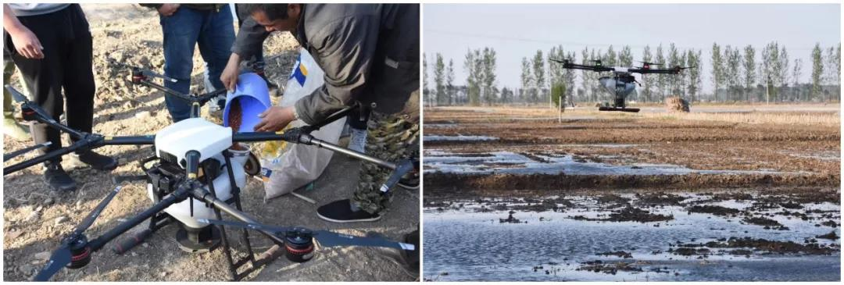
The MG Spreading System is designed specifically for MG series agricultural aircrafts, which can be replaced with tanks on MG series agricultural aircrafts and are perfect for spreading seeds, fertilizer, solid chemicals, fodder, and more. Recently, the DJI MG plant protection team conducted a direct rice seeding test with the MG Spreading System.

1. Environment Information
Time: May 2018
Location: Dawa District, Panjin, Northeastern China
Terrain: Plain
Weather: Sunny, 22°C with a gentle breeze from the southwest

When sowing seeds directly into the fields, we need to ensure the field is flat, the mud has sunk down to the bottom, and water remains at the surface.

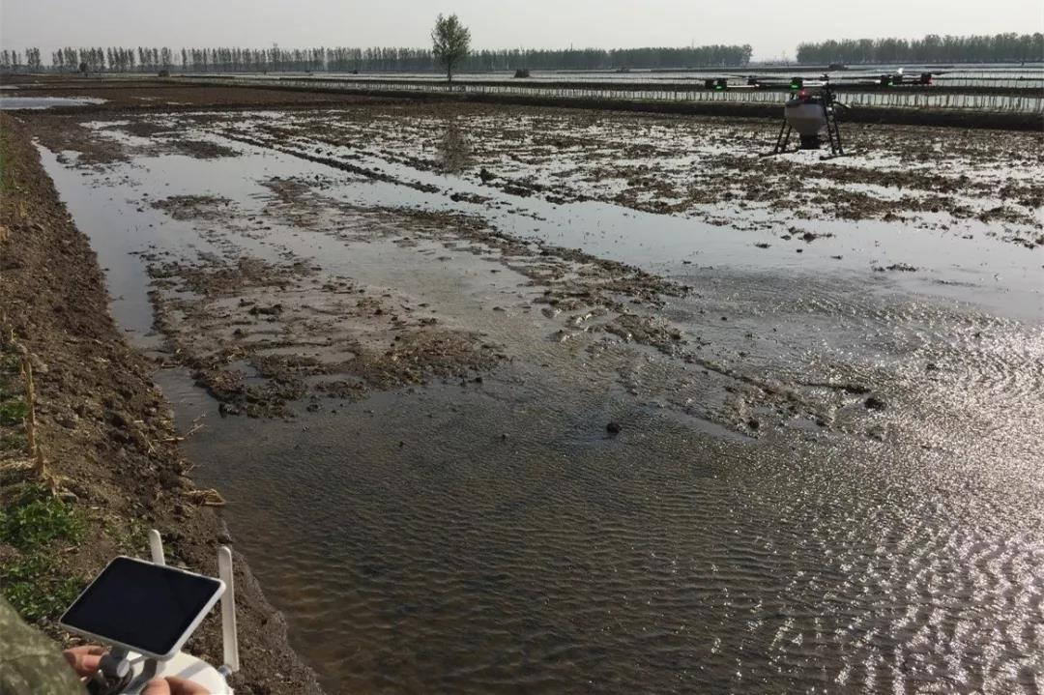

Conditions for paddy fields when sowing rice seeds.

2. Parameters
Flight Mode: A-B Route Operation Mode
Flight Speed: 1.2 m/s
Flight Altitude: 1.5 m
Spreading Space: 2.5 m
Rice Type: Yanfeng No. 47
Seeding Quantity per Acre: 447 g / 522 g/ 597 g
Spreading Area: 80.4 acres
Spinner Disk Rotating Speed: 520 rpm
Hopper Outlet Size: 60%

We divided the field into three groups. The spreading area of each group was 26.8 acres, the total spreading area was 80.4 acres, and we used rice seeds that were soaped for three days but hadn’t sprouted. Seeding quantity for each group was 447 g, 522 g, and 597 g respectively.

3. Spreading Effect
The MG Spreading System spreads seed evenly in the field, and also ensures a high survival rate. The images below show the seeds sprouting well in the first month.

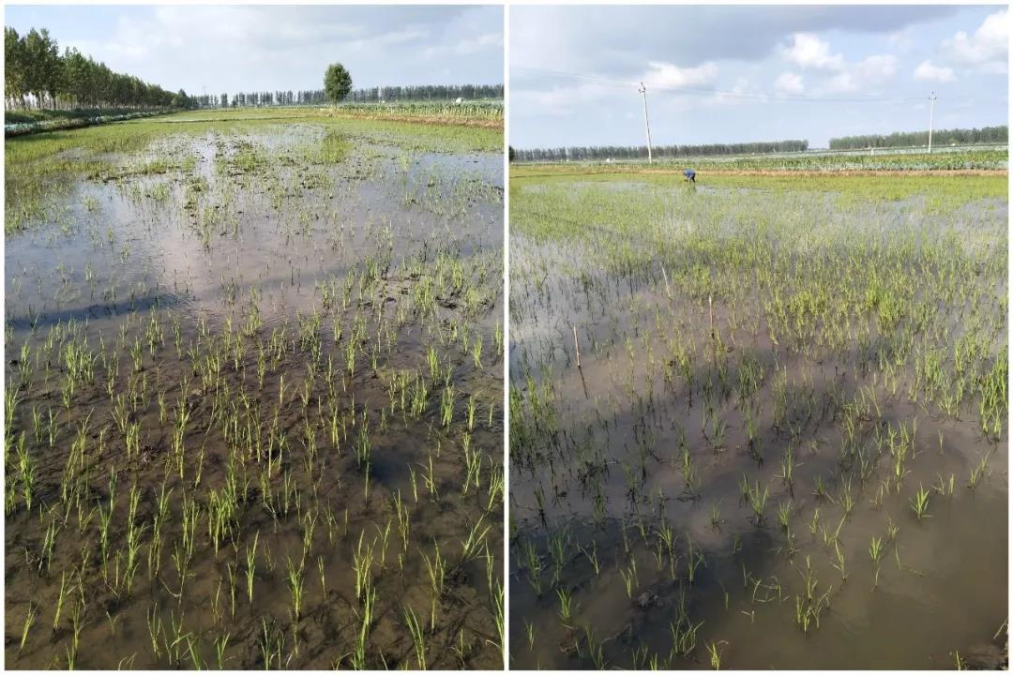
Rice seeds sprout after direct seeding with the MG Spreading System.

4. Conclusion

Farmers are very satisfied with the results that the MG Spreading System provided. By comparing the results of the three groups, we found the ideal seeding amount was 447g for one acre; the density would be too high if 522g or 597g of seeds are sowed per acre. The pilot Dagang Wang who helped in this test said that it’s very convenient to use the MG Spreading System to sow seeds. Both the hopper outlet size and the spinning disk’s rotating speed can be adjusted on a case-by-case basis to ensure even sowing. The history of sowing parameters can also be saved for future use or another operators’ reference.

